Factory (Creational)

Intent
Define an interface for creating an object, but let subclasses decide which class to instantiate. Factory Method lets a class defer instantiation to subclasses.

Also Known As
Virtual Constructor

Structure
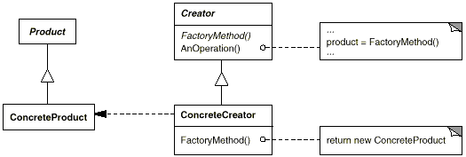

Participants
- Product (Document)
  - defines the interface of objects the factory method creates.
- ConcreteProduct (MyDocument)
  - implements the Product interface.
- Creator (Application)
  - declares the factory method, which returns an object of type Product. Creator may also define a default implementation of the factory method that returns a default ConcreteProduct object.
  - may call the factory method to create a Product object.
- ConcreteCreator (MyApplication)
  - overrides the factory method to return an instance of a ConcreteProduct.

Related Patterns
Abstract Factory (87) is often implemented with factory methods. The Motivation example in the Abstract Factory pattern illustrates Factory Method as well.
Factory methods are usually called within Template Methods (325). In the document example above, NewDocument is a template method.
Prototypes (117) don't require subclassing Creator. However, they often require an Initialize operation on the Product class. Creator uses Initialize to initialize the object. Factory Method doesn't require such an operation.

Abstract Factory (Creational)
- Intent
Provide an interface for creating families of related or dependent objects without specifying their concrete classes.
- Also Known As
Kit
- Structure
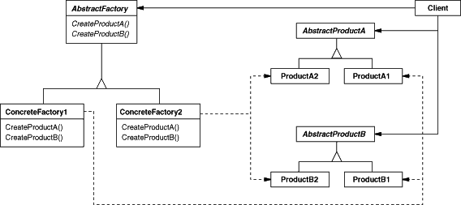
- Participants
- AbstractFactory (WidgetFactory)
  - declares an interface for operations that create abstract product objects.
- ConcreteFactory (MotifWidgetFactory, PMWidgetFactory)
  - implements the operations to create concrete product objects.
- AbstractProduct (Window, ScrollBar)
  - declares an interface for a type of product object.
- ConcreteProduct (MotifWindow, MotifScrollBar)
  - defines a product object to be created by the corresponding concrete factory.
  - implements the AbstractProduct interface.
- Client
  - uses only interfaces declared by AbstractFactory and AbstractProduct classes.
- Related Patterns
AbstractFactory classes are often implemented with factory methods (Factory Method (107)), but they can also be implemented using Prototype (117).
A concrete factory is often a singleton (Singleton (127)).

Prototype (Creational)

Intent
Specify the kinds of objects to create using a prototypical instance, and create new objects by copying this prototype.

Structure
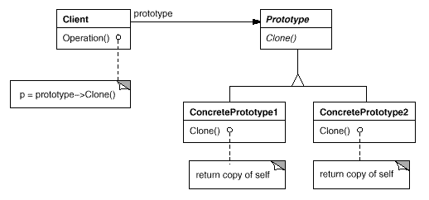

Participants
- Prototype (Graphic)
  - declares an interface for cloning itself.
- ConcretePrototype (Staff, WholeNote, HalfNote)
  - implements an operation for cloning itself.
- Client (GraphicTool)
  - creates a new object by asking a prototype to clone itself.

Related Patterns
Prototype and Abstract Factory (87) are competing patterns in some ways, as we discuss at the end of this chapter. They can also be used together, however. An Abstract Factory might store a set of prototypes from which to clone and return product objects.
Designs that make heavy use of the Composite (163) and Decorator (175) patterns often can benefit from Prototype as well.

Singleton (Creational)

Intent
Ensure a class only has one instance, and provide a global point of access to it.

Structure
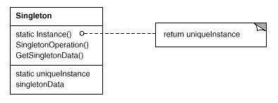

Participants
- Singleton
  - defines an Instance operation that lets clients access its unique instance. Instance is a class operation (that is, a class method in Smalltalk and a static member function in C++).
  - may be responsible for creating its own unique instance.

Related Patterns
Many patterns can be implemented using the Singleton pattern. See Abstract Factory (87), Builder (97), and Prototype (117).

Bridge (Creational)

Intent
Separate the construction of a complex object from its representation so that the same construction process can create different representations.

Structure
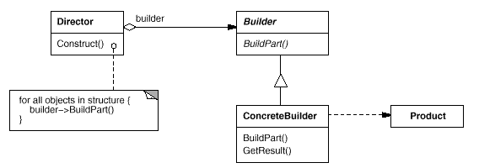

Participants
- Builder (TextConverter)
  - specifies an abstract interface for creating parts of a Product object.
- ConcreteBuilder (ASCIIConverter, TeXConverter, TextWidgetConverter)
  - constructs and assembles parts of the product by implementing the Builder interface.
  - defines and keeps track of the representation it creates.
  - provides an interface for retrieving the product (e.g., GetASCIIText, GetTextWidget).
- Director (RTFReader)
  - constructs an object using the Builder interface.
- Product (ASCIIText, TeXText, TextWidget)
  - represents the complex object under construction. ConcreteBuilder builds the product's internal representation and defines the process by which it's assembled.
  - includes classes that define the constituent parts, including interfaces for assembling the parts into the final result.

Related Patterns
Abstract Factory (87) is similar to Builder in that it too may construct complex objects. The primary difference is that the Builder pattern focuses on constructing a complex object step by step. Abstract Factory's emphasis is on families of product objects (either simple or complex). Builder returns the product as a final step, but as far as the Abstract Factory pattern is concerned, the product gets returned immediately.
A Composite (163) is what the builder often builds.

